November 9, 2024, San Marino, CA—

**H Foundation for the Arts**

**The Roastery @ H Foundation launches with solo exhibition of Takashi Horisaki— explores orientalism, history of bonsai and horticulture, and contemporary colonization in the increasing attention-deficit world**

**November 16 through December 21, 2024**

**The Roastery @ H Foundation for the Arts** is pleased to present *“****#ColonizingGazes: From Landscapes, Cyberscapes to Mindscapes***,” a solo exhibition of artist **Takashi Horisaki**’s ceramic sculpture from the #*InstaBonsai* series. This show is curated by Ann Shi in juxtaposition with “Auspicious Blooms: Sanyu and His Era,” curated by Dr. Shi Xiangdong in the main exhibition room. This is the inaugural exhibition for the launch of The Roastery @ H Foundation and the first solo exhibition of the artist in California. It will be on view from **November 16** through **December 21, 2024**. An opening reception will be held on Saturday, **November 16** at **3-6 PM**, and an artist talk will take place on **Saturday, December 21** at **3 PM** followed by closing reception till 6 PM.

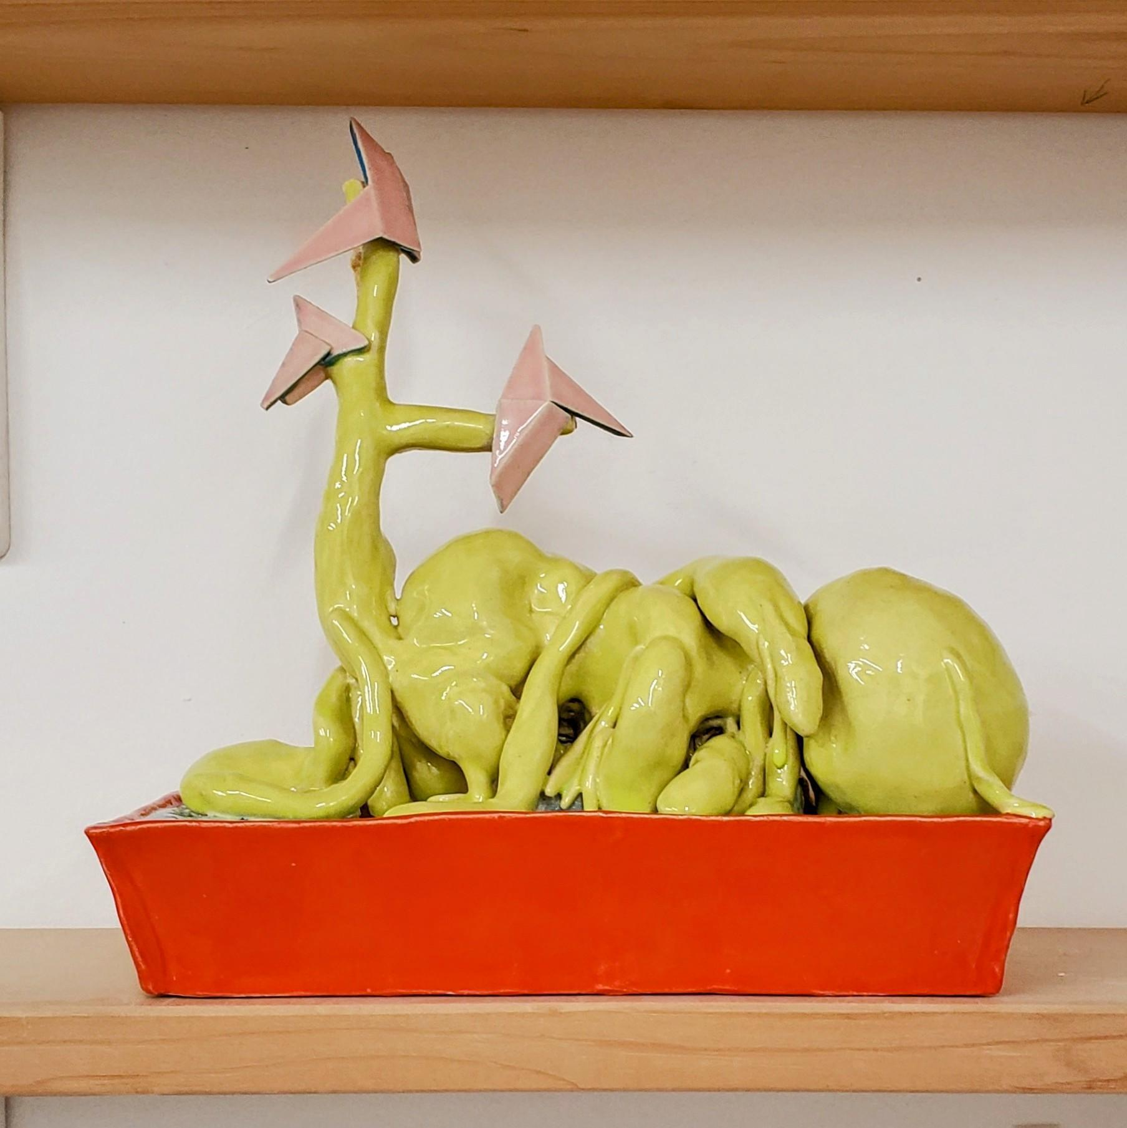

| Image: #InstaBonsai-BanyanY, 2022  **Takashi Horisaki**  ***#ColonizingGazes: From Landscapes, Cyberscapes and Mindscapes***  **OPENING: NOVEMBER 16, 3-6 PM**  **Artist’s Talk**: 3 PM, December 21, 2024  **Closing**: 3-6 PM, December 21, 2024 |
| --- |

**"We never look just at one thing; we are always looking at the relation between things and ourselves."**

**– John Berger, *Ways of Seeing* (1972)**

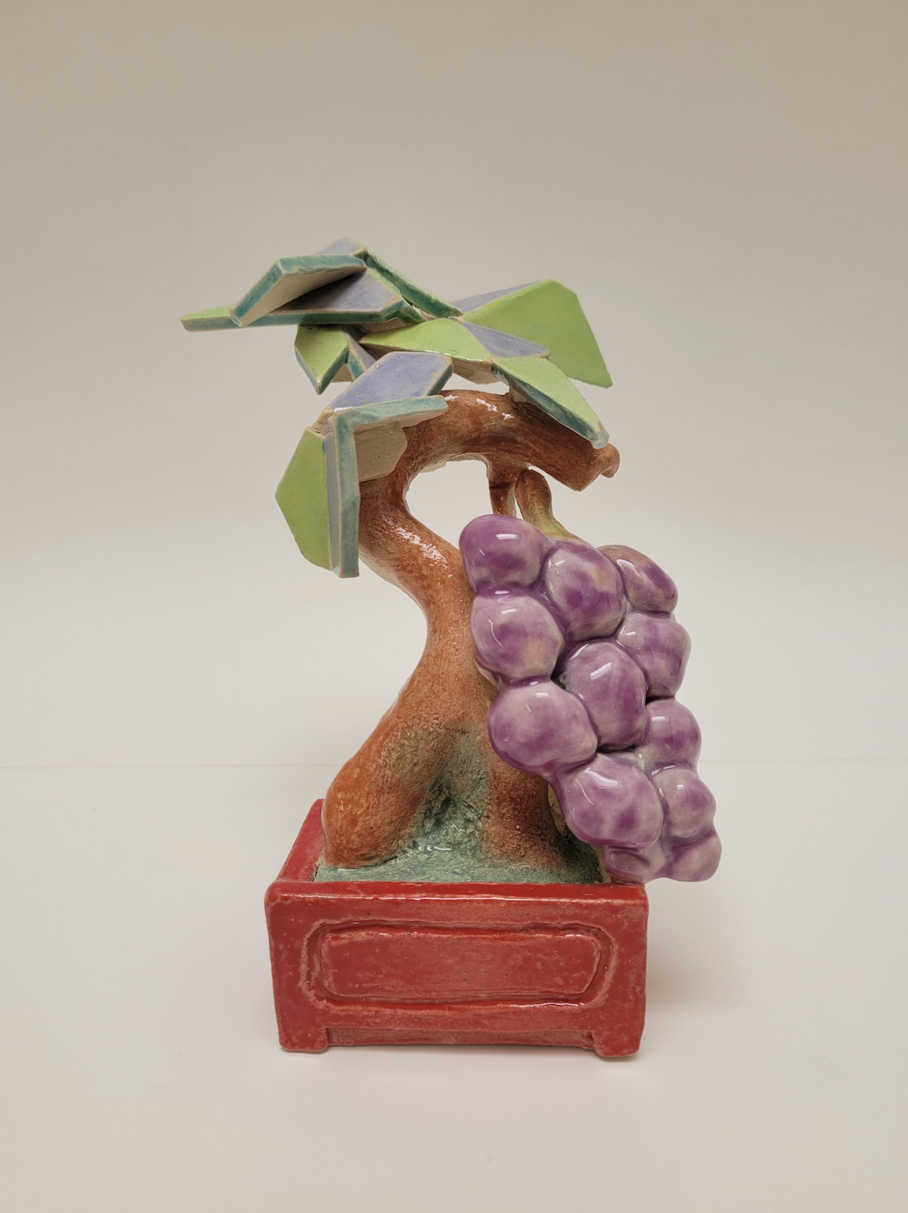

**Takashi Horisaki** presents his ceramic sculpture series, #*InstaBonsai,* that examines bonsai through the lens of social media, exploring and critiquing issues surrounding materiality and fluidity of cultural circulation, horticulture and the history of its aesthetics, and colonization in the new dimensionality of the current age.

The art of bonsai, originating in China as “penzai” and introduced to Japan in the 12th century, evolved across centuries into an emblematic form of Zen Buddhism and samurai refinement. In Japan’s Meiji to Taisho periods, bonsai was repurposed as a nationalist icon and propaganda instrument, embodying the complex interplay of cultural identity and aesthetic tradition. Horisaki’s *#InstaBonsai*, grounded in rigorous research, scrutinizes this colonial legacy, examining how nature is not merely appreciated but idealized and manipulated to align with cultural narratives.

Displayed on rotating displays that mimic a carefully curated retail setting, the sculptures emphasize the commodification of natural beauty while subtly invoking the environmental and historical fractures—colonialism, warfare, ecological degradation—that lie veiled beneath each carefully curated digital image. Crafted with a tactile, handmade approach, Horisaki’s works draw from Instagram imagery tagged with #bonsai and #盆栽, adopting a frontal, directed perspective that mirrors the structured gaze of digital visual culture. This gaze emerges from a place of unconscious conditioning, woven with commercial allure and impulses of colonization that traverse physical, digital, and psychological spaces.

In this manner, *#InstaBonsai* invites the viewer to confront both the seductive pull and underlying distortions of a world where our perceptions are increasingly pixelated, shaped by the intermediation of screens and the relentless drive to aestheticize and possess.

**TAKASHI HORISAKI** (b. 1974, Tokyo) is a sculptor and community-based artist, working across Los Angeles, New York, and Tokyo. His work draws inspiration from architecture, urban planning, and material culture, exploring how our physical environment connects to issues of social inequality, community strength, migration, and cultural exchange. Using materials like latex, ceramics, and plastic, Horisaki molds and reshapes familiar objects, transforming their form, structure, or color to create symbols of our surroundings. His approach combines these objects with storytelling elements—captured in oral histories, photographs, social media posts, and augmented reality—inviting us to consider the role of physical spaces in a world where digital and physical experiences increasingly merge.

Horisaki’s work has been exhibited internationally at venues including SPRING/BREAK Art Show (LA 2024, NY 2023, 2020, 2017, 2016, 2012), BankArt 1929’s R16 Studios in Yokohama (2018), Recess Soho (NY, 2014), the Contemporary Art Museum St. Louis (2012), Sculpture Center (NY, 2012), Seoul Art Space Geumcheon (Korea 2012), Deutsches Hygiene-Museum (Dresden, 2008), Prospect.1 Biennale (NOLA, 2008), and Queens Museum (NY, 2008). Currently, Horisaki is an artist-in-residence at the 18th Street Arts Center in Santa Monica, CA.

Instagram: [@socialdress](http://www.instagram.com/socialdress), [www.takashihorisaki.com](http://www.takashihorisaki.com)[18th Street Arts Center residency artist](https://18thstreet.org/artists/takashi-horisaki/)

**Ann Shi** is an independent curator, art appraiser, Chinese paintings specialist and art advisor based in New York, Los Angeles, and Houston. She is also an art archivist whose work centers on elevating and documenting artists in the diaspora, with a particular focus on those recontextualizing Contemporary Asia of their own times in history. Her curatorial approach navigates both indigenous and external perspectives within art history, exploring fresh narratives around Asian identity in contemporary art. Shi worked in Rice University Chao Center for Asian Art and Moody Center for the Arts as an associate curator and assistant curator respectively, and has continued to serve as a curatorial advisor for Houston Asian American Archive.

Shi is the newly appointed curator and program manager of H Foundation for the Arts, appointed by founder and executive director Tina He. She is also the founder of a poco art collective, an experimental art incubator located in an apartment space.

**About The Roastery @ H Foundation:**

The exhibition is supported by the H Foundation and curated by Ann Shi. This opening marks the launch of “The Roastery” as a vibrant incubator for emerging artists, providing a platform for innovative artistic exploration and interdisciplinary dialogues. Through curated exhibitions, residencies, and collaborative workshops, The Roastery aims to foster experimentation and creative development, empowering young artists to push boundaries and redefine their practice. H Foundation is a 501(c)3 non-profit organization focusing on supporting art and artists of the diasporic Asian communities or those whose work navigates the ideas of Asia.

The program emphasizes mentorship, connecting new artists with established figures in contemporary art, and encourages diverse, boundary-pushing approaches. By providing access to resources and a supportive community, The Roastery @ H Foundation aspires to nurture talent and contribute meaningfully to the broader cultural landscape, making it a valuable launchpad for artists like Horisaki, whose practice poses an alternative perspective for the traditional ideals.

Instagram: @h_foundation_for_the_arts, [www.h4arts.org](http://www.cfzdh.org)